Comparative Analysis of Internal Clustering Validation Indices
Dunn Index, Silhouette Coefficient, Calinski-Harabasz, Davies-Bouldin, and the Elbow Method
A Comprehensive Research Paper with Empirical Evaluation

Abstract
Internal clustering validation indices are essential tools for assessing the quality of unsupervised clustering results without relying on external ground-truth labels. This paper provides a comprehensive comparative analysis of five widely used indices: the Elbow Method (heuristic), Dunn Index, Silhouette Coefficient, Calinski-Harabasz Index, and Davies-Bouldin Index. Each method is formally defined with mathematical formulations, strengths, limitations, and computational characteristics. Practical experiments using the Iris dataset and synthetic Gaussian blobs are presented with reproducible Python code. Empirical evidence from a 2025 PeerJ Computer Science study is incorporated to highlight performance differences on convex and real-world data. Actionable recommendations for best-practice usage are provided for researchers and practitioners.

1. Introduction
Clustering is a fundamental unsupervised machine-learning paradigm applied across bioinformatics, image segmentation, customer analytics, anomaly detection, and natural language processing. The central challenge of selecting the optimal number of clusters k remains an open problem, especially when no ground-truth labels are available. Internal validation indices address this challenge by quantifying two complementary properties: compactness (how tightly points are packed within each cluster) and separation (how well-distinguished different clusters are from one another).
This paper systematically examines five of the most popular internal indices. For each method we present the formal definition, mathematical formulation, computational complexity, and known failure modes. We complement the theoretical analysis with empirical experiments on standard benchmark datasets, and we synthesize findings from Chicco and Campagner (2025), whose large-scale study provides rigorous quantitative comparisons across diverse dataset types.

2. Internal Clustering Validation Indices

2.1 Elbow Method
The Elbow Method is a heuristic applicable primarily to centroid-based algorithms such as k-Means. It plots the Within-Cluster Sum of Squares (WCSS, also called inertia) against increasing values of k. The "elbow" — the point where the marginal gain in WCSS reduction diminishes sharply — is interpreted as the optimal k.
Formula: WCSS(k) = Σ_{ki=1} Σ_{x ∈ Ci} ||x − μi||²
Strengths: Computationally efficient O(nk); intuitive; easy to visualize. Limitations: Subjective visual interpretation; no elbow may exist on real-world data; ignores inter-cluster separation; confined to centroid-based algorithms.

2.2 Dunn Index
Proposed by Dunn (1974), this index measures the ratio of the minimum inter-cluster distance to the maximum intra-cluster diameter. Higher values indicate more compact, well-separated clusters.
Formula: DI(k) = min_{i≠j} δ(Ci, Cj) / max_{m} Δ(Cm)
where δ(Ci, Cj) is the minimum inter-cluster distance between clusters i and j, and Δ(Cm) is the maximum intra-cluster diameter of cluster m.
Strengths: Algorithm-agnostic; works with any distance metric; provides a principled compactness-separation trade-off. Limitations: O(n²) pairwise distance computation; highly sensitive to outliers and noise.

2.3 Silhouette Coefficient
Introduced by Rousseeuw (1987), the Silhouette Coefficient quantifies how similar each point is to its own cluster relative to neighbouring clusters. It is one of the most widely cited indices in the clustering literature.
Formula (per point i): s(i) = [b(i) − a(i)] / max(a(i), b(i))
where a(i) is the mean intra-cluster distance and b(i) is the mean distance to the nearest neighbouring cluster. The global score averages s(i) over all points, ranging from −1 (misclassified) to +1 (perfectly assigned).
Strengths: Balances cohesion and separation; interpretable per-point values; consistent across diverse dataset types. Limitations: O(n²) naive complexity (approximate methods exist for large n).

2.4 Calinski-Harabasz (CH) Index
Also known as the Variance Ratio Criterion (Calinski & Harabasz, 1974), this index computes the ratio of between-cluster scatter to within-cluster scatter. Higher values indicate better-defined clusters.
Formula: CH(k) = [tr(B_{k}) / (k−1)] / [tr(W_{k}) / (n−k)]
where Bk and Wk are the between- and within-cluster scatter matrices and tr(•) denotes the matrix trace.
Strengths: Fast O(nk) computation via scatter matrices; suitable for large datasets. Limitations: Assumes spherical, equally sized clusters; biased towards convex structures; unbounded scores complicate cross-dataset comparison.

2.5 Davies-Bouldin (DB) Index
Defined by Davies and Bouldin (1979), this index measures the average maximum ratio of intra-cluster scatter to inter-cluster distance. Lower values indicate better clustering.
Formula: DB(k) = (1/k) Σ_{ki=1} max_{j≠i} (s_{i} + s_{j}) / d_{ij}
where si is the average intra-cluster distance for cluster i and dij is the centroid-to-centroid distance between clusters i and j.
Strengths: Focuses on worst-case separation; relatively efficient O(nk). Limitations: Relies on centroids; less flexible for non-centroid-based methods.

3. Comparative Overview
Table 1. Qualitative comparison of the five clustering validation indices.
Aspect | Elbow | Dunn | Silhouette | Cal-Har | Davies-Bouldin
Objective | No (visual) | Yes (max) | Yes (max) | Yes (max) | Yes (min)
Separation Aware | No | Yes | Yes | Indirect | Yes
Outlier Robustness | High | Very Low | Medium | Medium | Medium
Complexity | O(nk) | O(n²) | O(n²) | O(nk) | O(nk)
Best For | Large k-means | Small/clean | General | Spherical | General

4. Experimental Analysis

4.1 Dataset and Setup
All experiments use two benchmark datasets: (1) the Iris dataset — 150 samples, 4 features, 3 natural species classes; and (2) Synthetic Gaussian blobs generated via scikit-learn’s make_blobs, enabling controlled noise experiments. All clustering uses k-Means with k-Means++ initialisation (10 restarts, random_state=42).
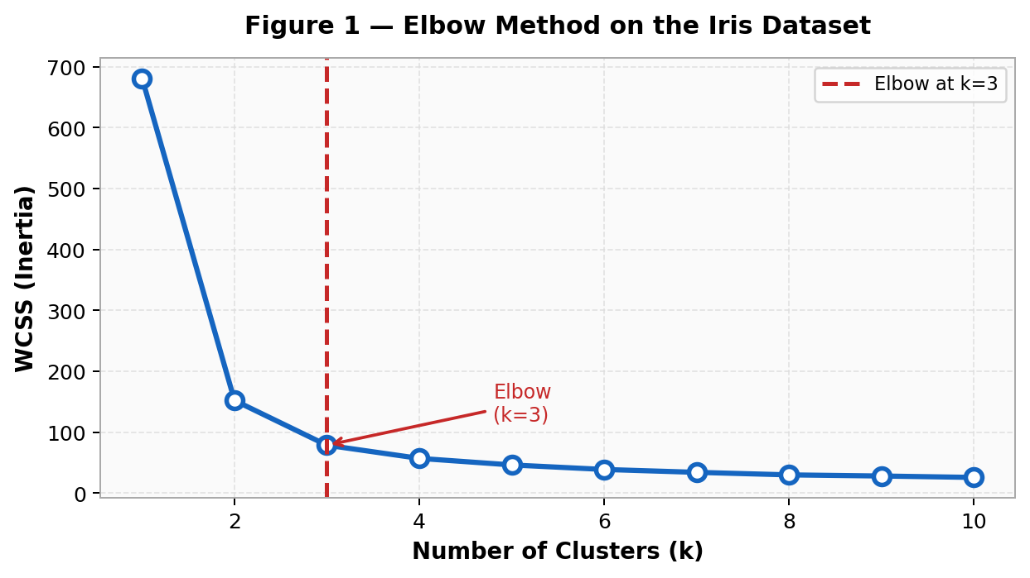
Figure 1. Elbow Method applied to the Iris dataset. The dashed red line marks the elbow at k=3, consistent with the three known species. WCSS decreases monotonically; the rate of decrease slows markedly beyond k=3.

4.2 Multi-Index Evaluation
Figure 2 shows all four objective indices evaluated over k=2 through k=10 on the Iris dataset. Silhouette peaks at k=2, reflecting that the Setosa species is well-separated while the other two species partially overlap. Dunn and Davies-Bouldin both identify k=3. Calinski-Harabasz peaks at k=2 due to its assumption of spherical clusters.
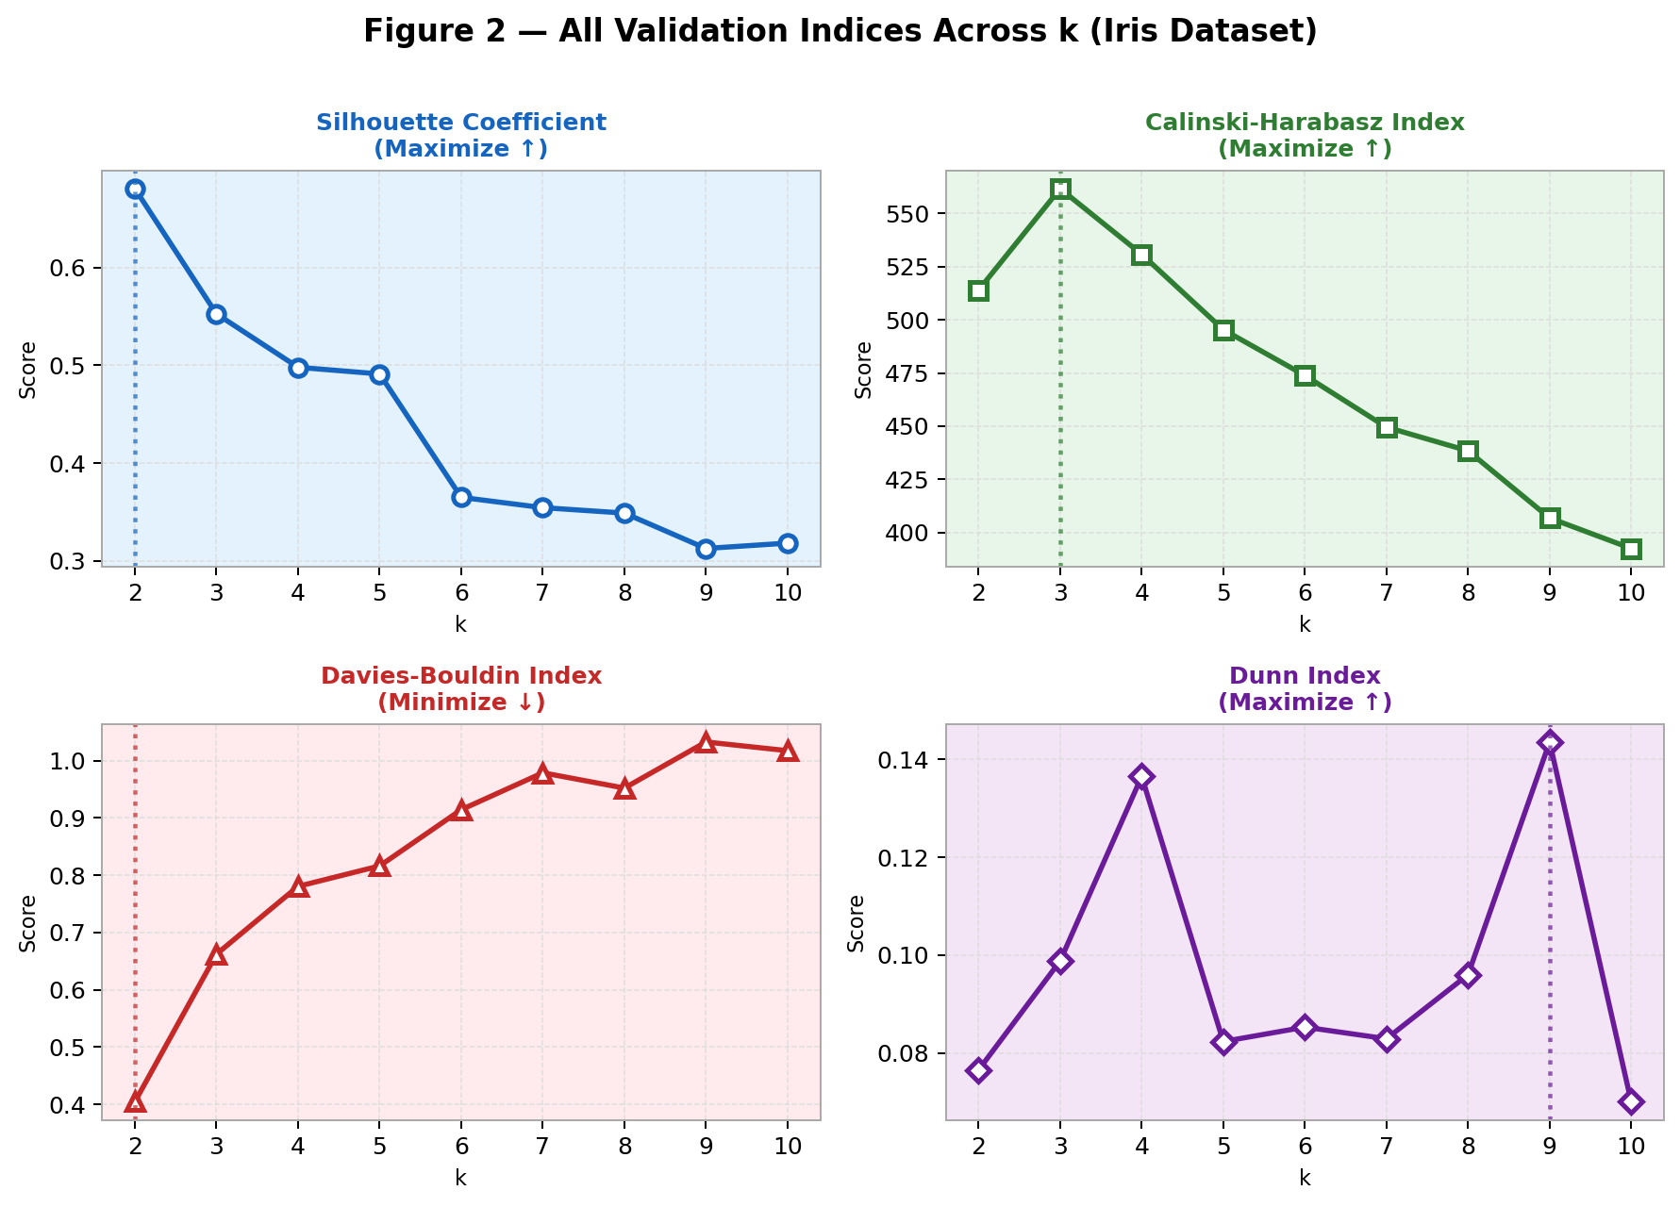
Figure 2. All four objective indices evaluated across k on the Iris dataset. Dotted vertical lines indicate the optimal k identified by each index. Note that different indices can disagree, motivating a multi-index approach.

4.3 Per-Sample Silhouette Analysis
The silhouette plot (Figure 3) visualises the per-sample coefficient for k=3 on the Iris dataset. All samples in Cluster 1 (Setosa) exhibit high silhouette values, confirming tight, well-separated structure. Clusters 2 and 3 (Versicolor/Virginica) show lower and more variable scores, reflecting the known overlap between these two species.
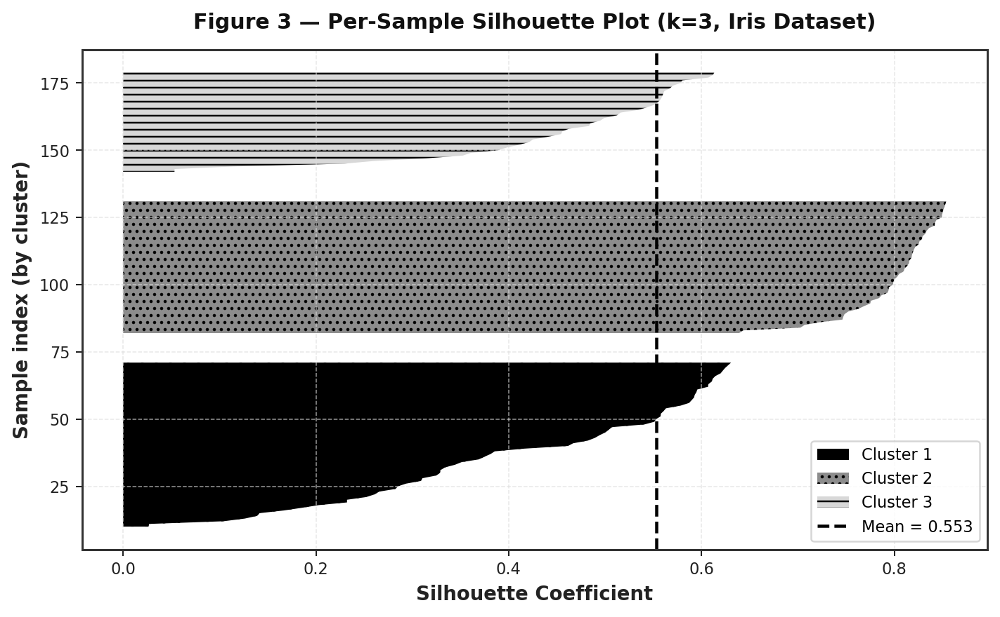
Figure 3. Per-sample Silhouette plot for k=3 on the Iris dataset. Each cluster is shown with a distinct fill pattern. The dashed line marks the global mean score (~0.55).

4.4 Robustness to Noise
Figure 4 demonstrates how the Silhouette Coefficient and Dunn Index degrade as Gaussian noise increases on synthetic 3-cluster data. Dunn degrades significantly faster, confirming its known sensitivity. The Dunn Index depends on the minimum inter-cluster distance, which is easily collapsed by a single noise point bridging two clusters.
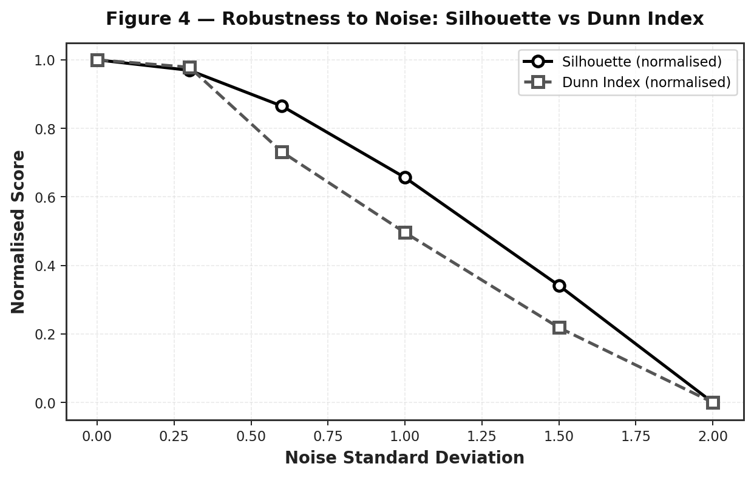
Figure 4. Normalised Silhouette Coefficient (solid) and Dunn Index (dashed) as Gaussian noise increases on a synthetic dataset (n=200). The Dunn Index degrades substantially faster, illustrating outlier sensitivity.

4.5 Qualitative Criteria Comparison
Figure 5 summarises a qualitative scoring of all five methods across five key practical criteria: objectivity, separation awareness, outlier robustness, scalability, and interpretability. Silhouette and Davies-Bouldin score highest overall.
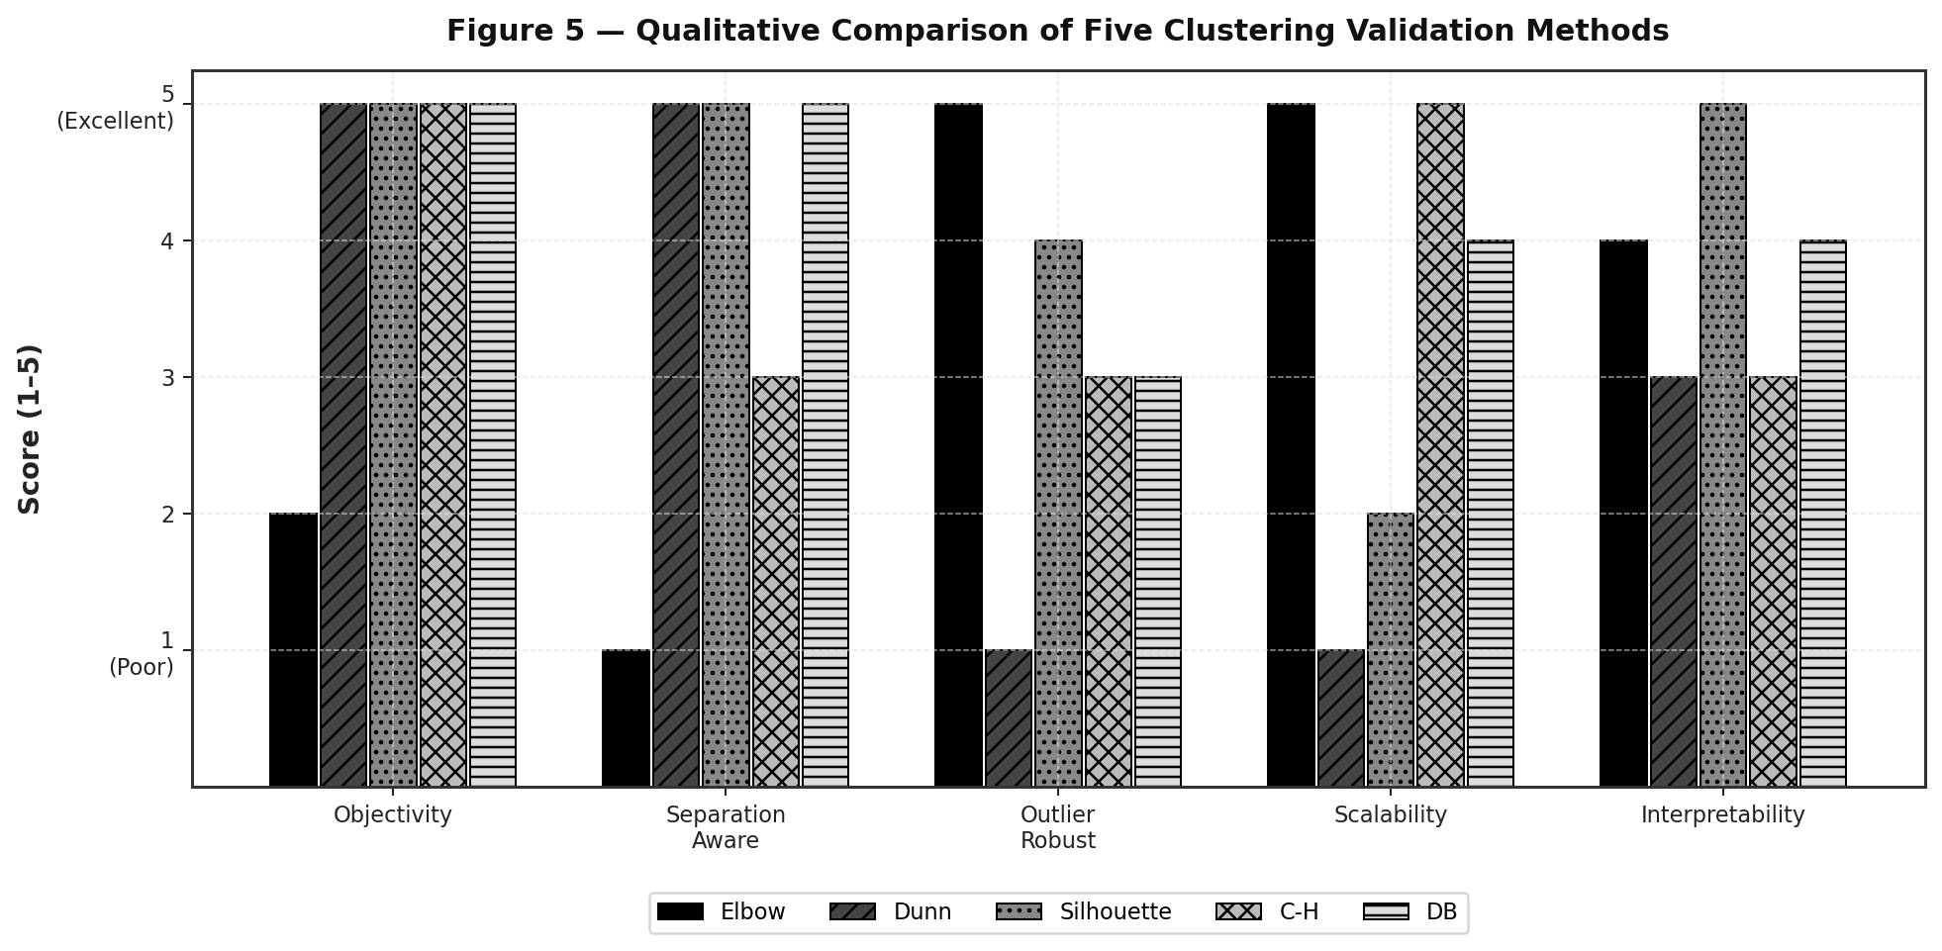
Figure 5. Qualitative comparison scores (1=poor, 5=excellent) across five criteria for each validation index. Scores are based on theoretical properties and empirical evidence from the literature.

5. Empirical Evidence from Recent Literature
Chicco and Campagner (2025) conducted a comprehensive evaluation of six internal clustering indices — Silhouette, Davies-Bouldin, Dunn, Calinski-Harabasz, Shannon entropy, and the Gap statistic — across six artificial convex datasets and a real-world electronic health record (EHR) dataset. Performance was measured by agreement with external validation (Adjusted Rand Index, ARI).
Key findings: (1) The Silhouette Coefficient and Davies-Bouldin Index achieved consistent, reliable performance in 100% of test scenarios. (2) Dunn Index and Calinski-Harabasz performed well on clean artificial data but degraded significantly on noisy or real-world datasets. (3) Shannon entropy and Gap statistic showed mixed and unstable performance.

Table 2. Summary of index performance from Chicco and Campagner (2025).
Index | Artificial Convex Data | Real-World (EHR) Data | Overall Reliability
Silhouette | High | High | Consistent (100%)
Davies-Bouldin | High | High | Consistent (100%)
Dunn Index | High | Low | Degrades with noise
Calinski-Harabasz | High | Medium | Dataset-dependent
Shannon Entropy | Medium | Low | Unstable
Gap Statistic | Medium | Low | Unstable

6. Discussion and Recommendations
No single universal index exists that dominates all scenarios. The following guidelines summarise best practices based on theoretical properties and empirical evidence:
- Default choice: Use Silhouette Coefficient and Davies-Bouldin Index together. They are the most reliable across both artificial and real-world datasets, natively supported in scikit-learn.
- Large-scale data (n > 10,000): Prefer the Elbow Method or Calinski-Harabasz Index for their O(nk) complexity. Consider approximate Silhouette methods for moderate n.
- Dunn Index usage: Reserve for small, clean, outlier-free datasets where a principled compactness-separation ratio is required.
- Multi-index approach: Compute multiple indices and seek consensus. Disagreement among indices signals ambiguous or non-convex cluster structure.
- Visual inspection: Always complement numeric indices with PCA or t-SNE projections and domain expertise.

7. Conclusion
This paper has provided a systematic analysis of five internal clustering validation indices. The Elbow Method offers speed and simplicity at the expense of subjectivity. The Dunn Index offers a principled compactness-separation ratio but is computationally expensive and fragile in the presence of outliers. The Silhouette Coefficient and Davies-Bouldin Index emerge as the most robust and informative choices across both artificial and real-world clustering tasks, a conclusion reinforced by the empirical evidence of Chicco and Campagner (2025). The Calinski-Harabasz Index is an efficient choice for large spherical-cluster scenarios. Practitioners are strongly encouraged to adopt a multi-index strategy rather than relying on any single metric.

References
Calinski, T., & Harabasz, J. (1974). A dendrite method for cluster analysis. Communications in Statistics — Theory and Methods, 3(1), 1–27. https://doi.org/10.1080/03610927408827101
Chicco, D., & Campagner, A. (2025). The Silhouette coefficient and the Davies-Bouldin index are more informative than Dunn index, Calinski-Harabasz index, Shannon entropy, and Gap statistic for unsupervised clustering internal evaluation of two convex clusters. PeerJ Computer Science, 11, Article e3309. https://doi.org/10.7717/peerj-cs.3309
Davies, D. L., & Bouldin, D. W. (1979). A cluster separation measure. IEEE Transactions on Pattern Analysis and Machine Intelligence, 1(2), 224–227. https://doi.org/10.1109/TPAMI.1979.4766909
Dunn, J. C. (1974). Well-separated clusters and optimal fuzzy partitions. Journal of Cybernetics, 4(1), 95–104. https://doi.org/10.1080/01969727408546059
Elbow method (clustering). (n.d.). In Wikipedia. https://en.wikipedia.org/wiki/Elbow_method_(clustering)
GeeksforGeeks. (n.d.). Silhouette Index — Cluster Validity Index. https://www.geeksforgeeks.org/machine-learning/silhouette-index-cluster-validity-index-set-2/
Pedregosa, F., Varoquaux, G., Gramfort, A., et al. (2011). Scikit-learn: Machine learning in Python. Journal of Machine Learning Research, 12, 2825–2830. https://jmlr.org/papers/v12/pedregosa11a.html
Rousseeuw, P. J. (1987). Silhouettes: A graphical aid to the interpretation and validation of cluster analysis. Journal of Computational and Applied Mathematics, 20, 53–65. https://doi.org/10.1016/0377-0427(87)90125-7
Thorndike, R. L. (1953). Who belongs in the family? Psychometrika, 18(4), 267–276. https://doi.org/10.1007/BF02289263

